National College of Ireland

BSHC in Computing

2017/2018

Conor Conlon

X14499688

[X14499688@student.ncirl.ie](mailto:X14499688@student.ncirl.ie)

Retro Games Corner

Technical Report

Contents

1 Introduction 4

1.1 Background 4

1.2 Aims 4

1.3 Technologies 4

1.4 Structure 4

2 System 4

2.1 Requirements 4

2.1.1 Functional Requirements 4

2.1.2 Data Requirements 5

2.1.3 User Requirements 5

2.1.4 Environmental Requirements 5

2.1.5 Usability Requirements 5

2.2 Design Architecture 5

2.3 Implementation 5

2.4 GUI 5

2.5 Testing 5

2.6 Custom Testing 6

2.7 Evaluation 6

3 Conclusions 6

4 Further Development of research 6

5 References 6

6 Appendix 6

**Executive Summary**

The love of older games titles from consoles of the past years is steadily growing along with the communities around them. In the past two years Nintendo have released two previous generation console packages with many classic games included, both have been very successful and highly sought after. The community around collection of older games have recently seen a rise in bootleg products; reproduced versions of popular games get sold online and also to games retail stores. The circulation of these products is seen by the community as a plague. Some collectors keep multiples of a game waiting for the value to rise (it is very unusual for many of these older games to go down in value), this is hard to judge unless there is some particular reason such as a re-release of a title.

My web service aim to provide this community with a platform where they can show of their collection, check and see the current popularity of titles and also advertise sale of games to other members of the community.

# 1 Introduction

Video Gaming is an industry that continues to grow and holds its past with high regard. These older releases and the collectors whom pursue them are the market this service is geared towards.

# Background

With older titles getting re-mastered releases on current generation consoles we see jumps in the original versions value. This is a hard number to accurately assess due to the fact that once popularity for a title gathers; the market gets flooded with high priced copies and also counterfeit copies. My service is a safe platform for the fans and collectors of these previous generation games.

# Aims

Retro games collection is a hobby driven by the love people have for these games and the enjoyment they bring. This service will be a platform for this market. The end user has a new place online to show their love for their favourite games, keeping a digital record of their collection and also displaying details on games they would like to sell are also services available on the site. Google trends API will also be used on the site in order to allow users to check the popularity of titles they may have and wish to sell, user’s will also be able to query the database of games that is all the games collections of the services users, with this functionality they can view the owners email and email them if they would like to enquire about the game or offer them a price for the game.

# Technologies

A Django REST API will be used for the web service, this is basically a MVC approach with user interaction being handled by calls to the API. The front end will be developed with HTML for design and CSS for style. Google tends API will be integrated to the service to allow users to submit queries and view the popularity of titles from a number of different perspectives. The search games function will use GET request to the games collection database in order to retrieve data for the user.

# Structure

The project will be a Django rest project within python environment. The initial set-up includes a single model which allows GET, POST, PUT and DELETE requests. This will be modified to allow creation of a user model to allow users to create a profile with the site. Next I will create the games collection model to allow users to add games to their digital collection list.

# 2 System

# 2.1 Requirements

# 2.1.1 Functional Requirements

The system must capture user input and then add a new entry to the user models based on this input. These are the entries that will be required when a user is creating a profile: *username*, *email*, *password*, *favourite console* and *why you love retro games*. The system must also capture input when a user is logging in; this will be the previous mentioned *username* and *password*. Provided these can be authenticated the system will grant the user permissions to use the add-game function of the site. The system will allow all users to submit a query with the google trends function. This will take in user input and require that a tick box be selected

The system must allow a user to create a profile on the service and login using a username and password. The system will allow users to add games to a digital collection that will be stored and then associated with the user’s profile. The system will allow users to submit a search to Google trends and the information will then be displayed to the user.

# 2.1.2 Data Requirements

The system uses a framework very similar to Model View Controller and SQLite as a database. Each model will be clearly defined. There will be a user model and a game model. The user model will take parameters : *username*, *email*, *password*, *favourite console* and *why you love retro games.* The game model will take *Game Title*, *Console/s, Rating, Description* and *Fond Memories* The game for sale model will take parameters

# 2.1.3 User Requirements

The system must allow a user to create a profile on the service and login using a username and password. The system will allow users to add games to a digital collection that will be stored and then associated with the user’s profile and lastly the system will allow users to submit a search to Google trends and the information will then be displayed to the user.

# 2.1.4 Usability Requirements

All functions of the site will be accessible within three clicks; a navigation bar across the top of the UI will allow this using resources of the service.

# 2.2 Design Architecture

The site will developed using python Djangorest framework with html and css on the front end. There will be a model for user, games collection and game for sale, serializers will allow the data to be retrieve from the datasets and pass it to the views.py file in a human readable format. Requests within the views.py file will retrieve the different urls of the service and present them to the user. A plugin called PyTrends will be used for the Google trends feature.

Class Diagram:

GamesCollection

+Id:int()

USER

*

1.

+title:string()

+Id:int()

+Name:String()

+Description:string()

+Email:String()

+EditTitle()

1.

+AddGamesS()

+AddGamesC()

+EditDescription()

+DelGamesC()

+UpdateGamesC()

+DelGamesS()

# 

+UpdateGamesS()

GamesSellCollection

*

+title:string()

+Id:int()

+Description:string()

+Price:string()

+EditDescription()

+EditTitle()

+EditPrice()

# 2.3 Implementation

The API will handle all GET, POST, PUT, PATCH and DELETE requests. Model classes will be used to represent the different entities of the service.

# 2.4 GUI

Homepage:

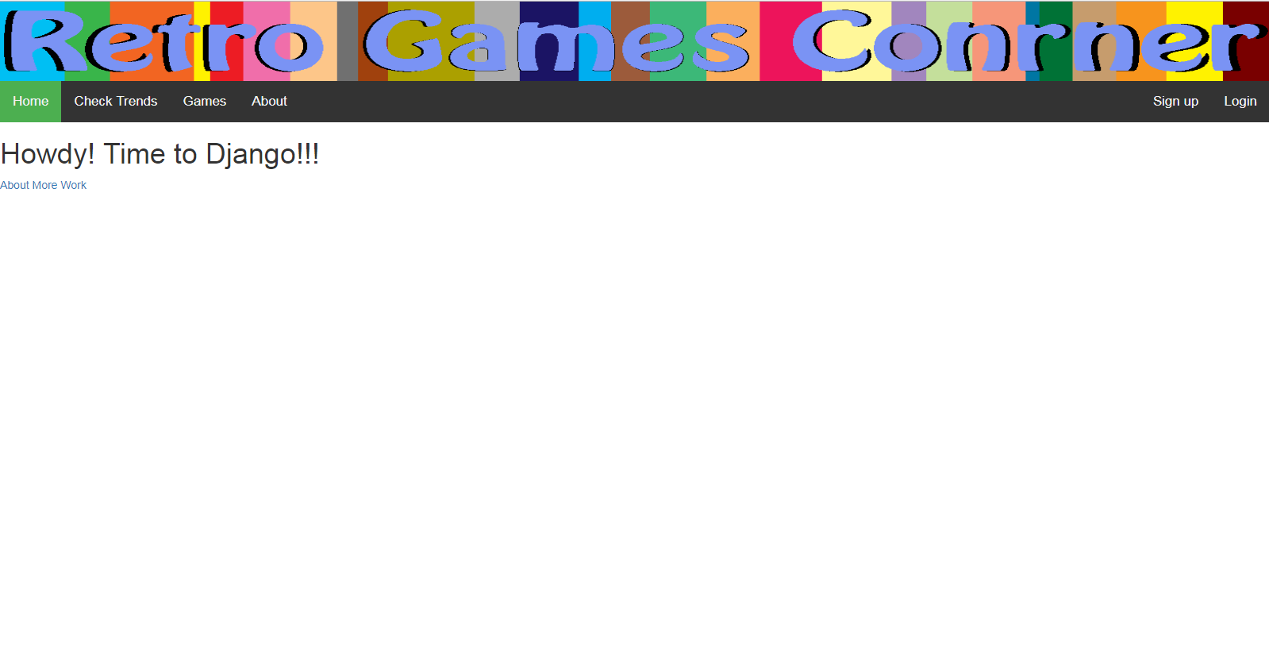

REST:

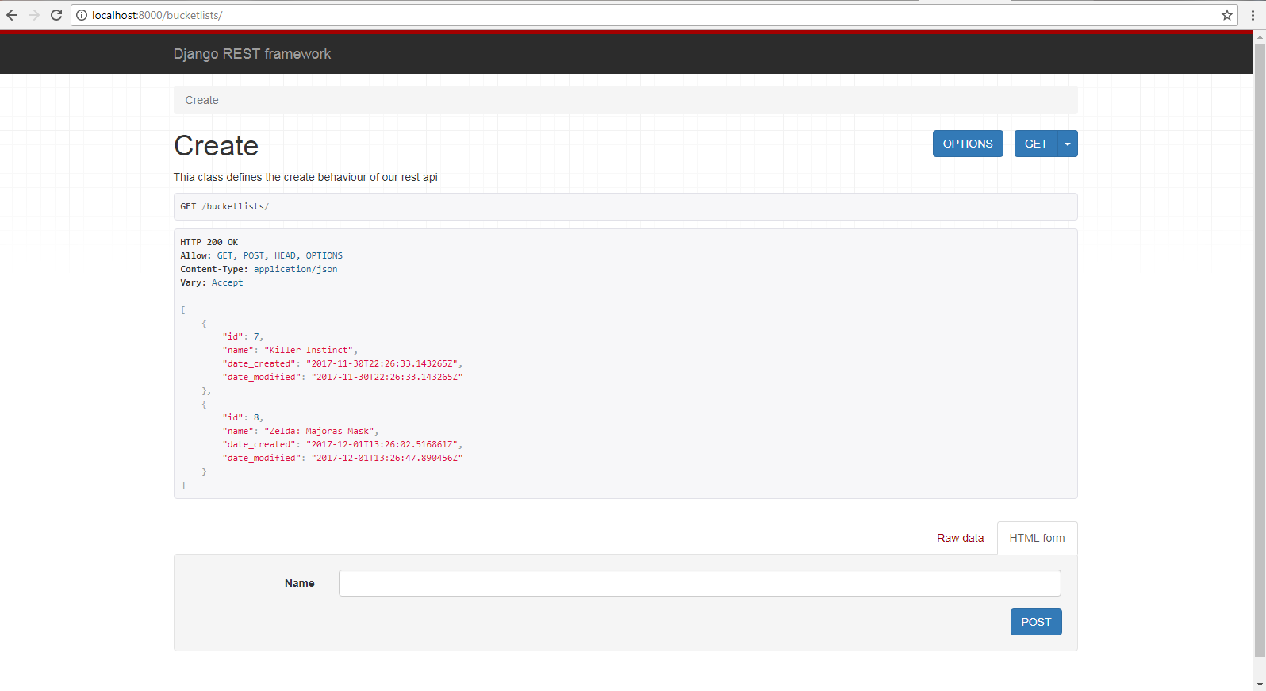

# 2.5 Testing

# 2.6 Custom Testing

# 2.7 Evaluation

# 3 Conclusions

# 4 Further Development of research

# 5 References

# 6 Appendix